(Problem Number): (Problem Name) (Date)

**Problem 1 : Name of Problem(font size 16, font type: Calibri)**

**AIM:(font size 13, font type: Calibri, bold and underlined)**

Text here(font size 12, font type: Calibri)

**ALGORITHM:(font size 13, font type: Calibri, bold and underlined)**

Text here(font size 12, font type: Calibri)



Algorithm-1 Text here(font size 12, font type: Calibri)

Algorithm-2 Text here(font size 12, font type: Calibri)

**PROGRAM CODE: (font size 13, font type: Calibri, bold and underlined)**



|  |  |  |  |  |
| --- | --- | --- | --- | --- |
| File1.html | | | **(font size 12, font type: Lucida Console)** |  |
| **(font size** | | | <html> |  |
| **1** | **2** | **, font** | ….. |  |
|  |  |
| **type:** | | | ….. |  |
| **Calibri)** | | |  |
| ….. |  |
|  |  |  |  |
|  |  |  | </html> |  |
| File2.html | | | …………code…………………………… |  |
| File3.css | | | ………………code………………………… |  |
| filename | | | Code………….. |  |
| …….. | | | ……… |  |
| ……… | | | ………. |  |
| File N | | | ………code…………….. |  |

Web Programming Lab (Pg.No)

(Problem Number): (Problem Name) (Date)

**RESULT(font size 13, font type: Calibri, bold and underlined)**

Text here(font size 12, font type: Calibri)

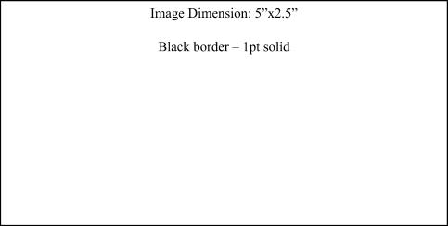

Figure 1:Details about the figure



Figure 2:Details about the figure



Figure 2:Details about the figure

Web Programming Lab (Pg.No)